**Smart Transportation System**

**(Virginia Tech Joint Training)**

**Team Members:**

Muhammad Soliman – 20100245

Youssef Badreldin – 20100294

**Project Description:**

* We aim to automate the AIU transportation system and make it smarter.
* We aim to provide a better experience for students.
* We aim to lighten the burden of the staff by organizing the transportation system.

**Requirements:**

* 1. The system should allow the users to register for the service system.

1.1 The system should provide facilities for users to register themselves.

1.1.1 The user should choose a username and a password according to the authentication rules.

1.1.2 The system should not allow users to have more than one account.

1.2 The system should verify the information of the user before letting the user on the service.

1.2.1. The system will verify the account using personal ID and email.

1.2.2 The system will differentiate users using their ID.

* 1. The system should have the vehicle’s information shown to the user

2.1 The system will show the user the vehicle’s licence plate.

2.2 The system will show the user the driver’s information

* 1. The system should allow each user to add the days he will use the vehicle.

3.1 The user should choose which days he will use the service (every day or every week)

3.2 The user should choose departure times if they are not standard.

* 1. The system should allow each user to add their pickup point.

4.1 The system should allow the user to choose the pickup point by either finding it on the map or entering it.

4.1.1 The system should confirm that the pickup point is correct.

* 1. The system should allow each user to have their pickup time shown.

5.1 The system should calculate the estimated time of the vehicle’s arrival to the pickup point.

* 1. The system should allow the user to see live location of the vehicle.

6.1 The user should see the vehicle’s live location on the map.

* 1. The system should notify the user about the vehicle’s arrival.

7.1 The system should send notification when the vehicle arrive.

7.2 The system should give a 5 minute limit waiting time for the user.

* 1. The system should notify the user when the vehicle’s is close to the pickup point.

8.1 The system should allow the user to track the bus.

8.1.1 The system should notify the user when the bus is about to arrive.

* 1. The system should allow the user to have flexible payment plan.

9.1 The system should allow the user to choose the payment method (weekly, monthly or by semester)

* 1. The system should verify the user’s payment.

10.1 The user should upload what proves his payment and the system has to confirm whether it’s valid or not.

* 1. The system should have flexible reservations.

11.1 The System should allow the user to change his destination and it should not be fixed.

* 1. The system should report how many busses will needed for every route.

12.1 The system counts how many passengers on each route and divide them on capacity of the buses to count the number of busses on each route

12.1.2 The system reports if more busses are needed for the route and vice versa.

12.2 The system is optimized for all busses of any capacity

12.3 The system tries to minimizes the number of empty seats in each route

* 1. The system allow users to report a problem.

13.1 The system forwards the reports to the admin to be dealt with.

13.2 The system shows the status of the report to the passenger.

13.3 The system uses the reports to rate the busses drivers.

13.4 The system reports to the staff if a bus driver’s score is too low.

* 1. The system should be supported with a card readers for passengers (to take attendance).

14.1 The system counts the number of scanned cards and compares it to the number of students reserved for the bus for security.

14.1.2 The system reports if an unregistered students has entered the bus.

14.2 The system counts the number of redden cards and compares it to the number of students reserved for the bus for attendance.

* 1. The system should provide the staff with a daily report about passengers.

15.1 The system collects the data of passengers and sends them to the admin daily.

* 1. The system should provide the staff with a daily financial report when needed.

16.1 The system sends a report about the passengers and their financial status to the admin when needed.

**Use Case Diagram**

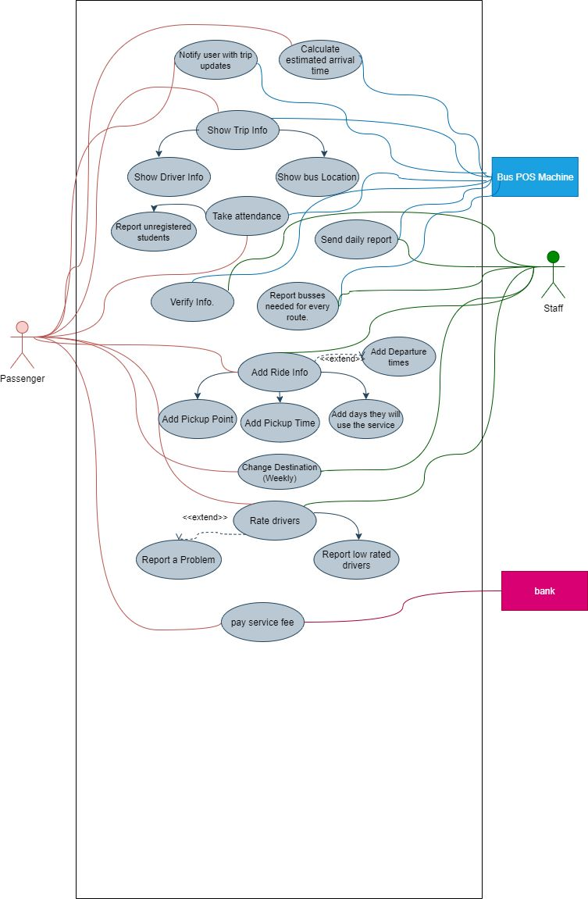



**Context Diagram**

